Non-Periodic Tessellation
# Source: AI Source: Provided by: [Data Path: Persons Table -> ID Column: 1, Name_En Column: Motasem Essam] -> From: [ChatGPT] on [7/25/2026]
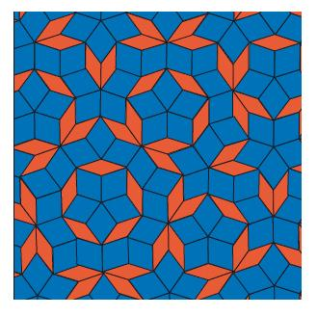
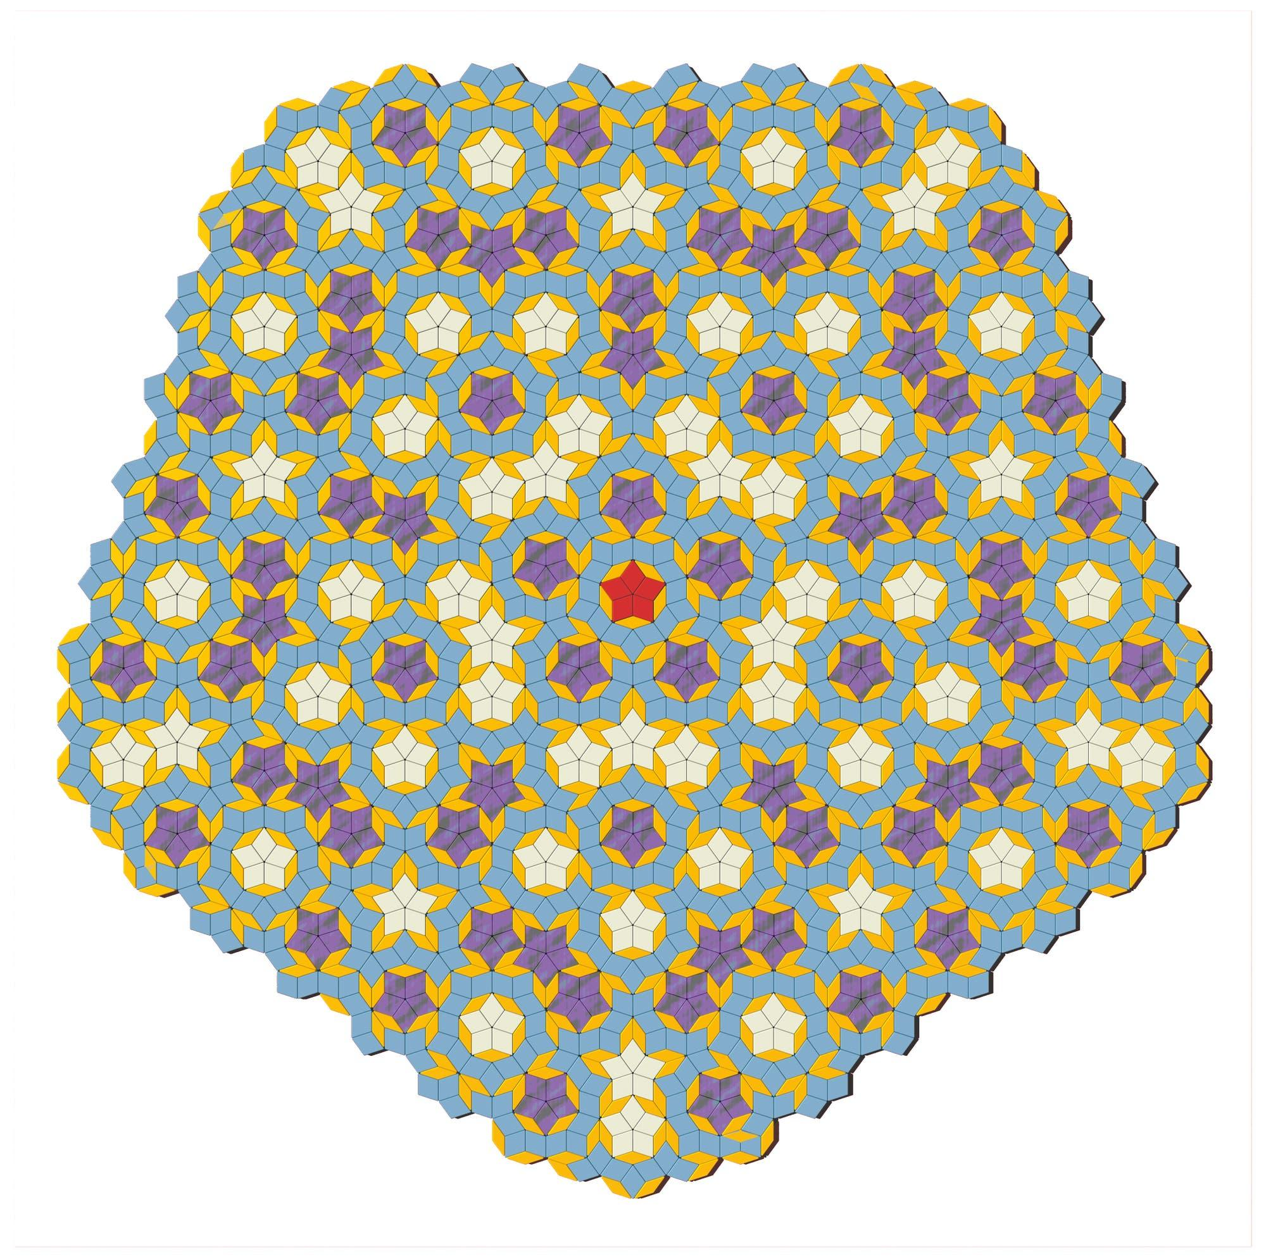
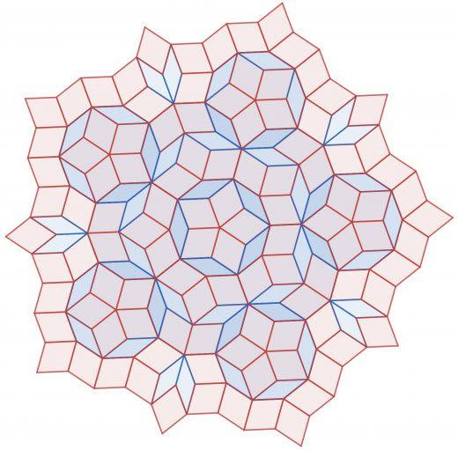
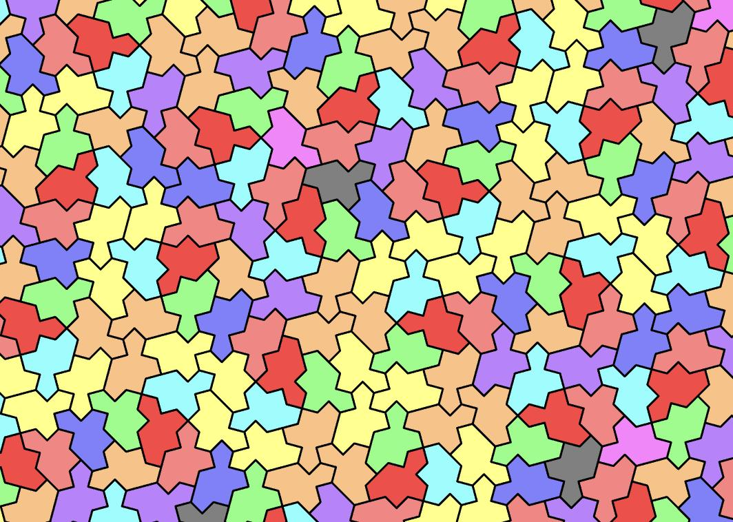
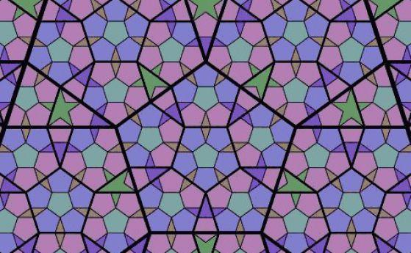

Definition
# Source: AI Source: Provided by: [Data Path: Persons Table -> ID Column: 1, Name_En Column: Motasem Essam] -> From: [ChatGPT] on [7/25/2026]
A Non-Periodic Tessellation is a tessellation of the plane that does not repeat through any non-zero translation.
In other words, there is no finite repeating pattern that can be translated in a fixed direction to reproduce the entire tessellation.
The defining property is:
$$\boxed{\text{No non-zero translational symmetry}}$$
A non-periodic tessellation can still cover the plane completely without gaps or overlaps.

Purpose
# Source: AI Source: Provided by: [Data Path: Persons Table -> ID Column: 1, Name_En Column: Motasem Essam] -> From: [ChatGPT] on [7/25/2026]
Non-periodic tessellations are used to:
- Study patterns without ordinary repetition.
- Explore geometric order without periodicity.
- Investigate symmetry and mathematical structure.
- Study aperiodic tilings.
- Model structures that have long-range order without translational repetition.

Fundamental Elements

1. Tile
# Source: AI Source: Provided by: [Data Path: Persons Table -> ID Column: 1, Name_En Column: Motasem Essam] -> From: [ChatGPT] on [7/25/2026]
A tile is an individual shape used to cover the plane.
A non-periodic tessellation may use:
- One type of tile.
- Two or more tile types.
- Regular polygons.
- Irregular shapes.
- Special shapes designed to force non-periodic arrangements.

2. Tessellation
# Source: AI Source: Provided by: [Data Path: Persons Table -> ID Column: 1, Name_En Column: Motasem Essam] -> From: [ChatGPT] on [7/25/2026]
The tiles must still satisfy the basic tessellation condition:
$$\boxed{\text{No gaps and no overlaps}}$$

3. Translation
# Source: AI Source: Provided by: [Data Path: Persons Table -> ID Column: 1, Name_En Column: Motasem Essam] -> From: [ChatGPT] on [7/25/2026]
A translation moves every point by the same vector:
$$\boxed{T_{v}\left(P\right)=P}$$
For a non-periodic tessellation, no non-zero translation vector reproduces the entire pattern:
$$\boxed{T_{v}\left(P\right)≠P \text{for }v≠0}$$

Periodic vs Non-Periodic
# Source: AI Source: Provided by: [Data Path: Persons Table -> ID Column: 1, Name_En Column: Motasem Essam] -> From: [ChatGPT] on [7/25/2026]
The fundamental difference is translation symmetry.
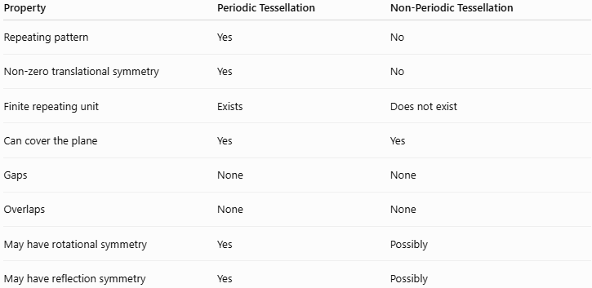
Property | Periodic Tessellation | Non-Periodic Tessellation
Repeating pattern | Yes | No
Non-zero translational symmetry | Yes | No
Finite repeating unit | Exists | Does not exist
Can cover the plane | Yes | Yes
Gaps | None | None
Overlaps | None | None
May have rotational symmetry | Yes | Possibly
May have reflection symmetry | Yes | Possibly

Important Distinction: Non-Periodic vs Random
# Source: AI Source: Provided by: [Data Path: Persons Table -> ID Column: 1, Name_En Column: Motasem Essam] -> From: [ChatGPT] on [7/25/2026]
A non-periodic tessellation is not necessarily random.
It can have a highly organized mathematical structure even though it does not repeat periodically.
For example, a Penrose tiling follows strict geometric rules but has no translational period.
Therefore:
$$\boxed{\text{Non-Periodic}≠\text{Random}}$$
A better description is:
$$\boxed{\text{Ordered but Non-Repeating}}$$
for many important examples.

Aperiodic Tessellation
# Source: AI Source: Provided by: [Data Path: Persons Table -> ID Column: 1, Name_En Column: Motasem Essam] -> From: [ChatGPT] on [7/25/2026]
An Aperiodic Tessellation is a stronger mathematical concept.
A set of tiles is called aperiodic if it can tile the plane, but every valid tiling produced by those tiles is non-periodic.
Thus:
$$\boxed{\text{Aperiodic Tile Set}⇒\text{Every Valid Tiling Is Non-Periodic}}$$
This distinction is important:
Non-Periodic Tessellation
Describes one particular tessellation that does not have translational periodicity.
Aperiodic Tile Set
Describes a set of tiles whose valid tilings are forced to be non-periodic.

Penrose Tiling
# Source: AI Source: Provided by: [Data Path: Persons Table -> ID Column: 1, Name_En Column: Motasem Essam] -> From: [ChatGPT] on [7/25/2026]
One of the best-known examples is the Penrose Tiling.
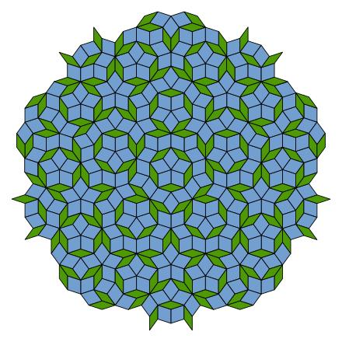
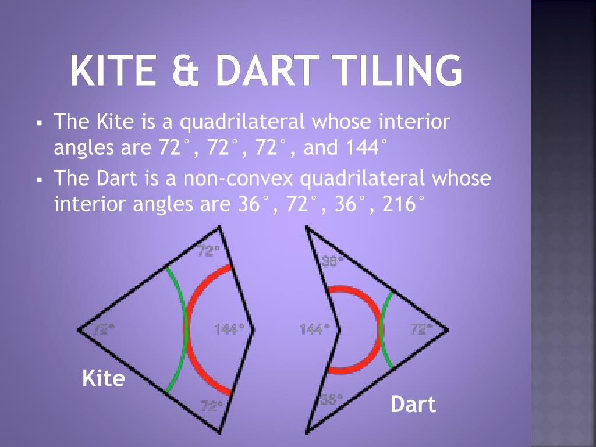
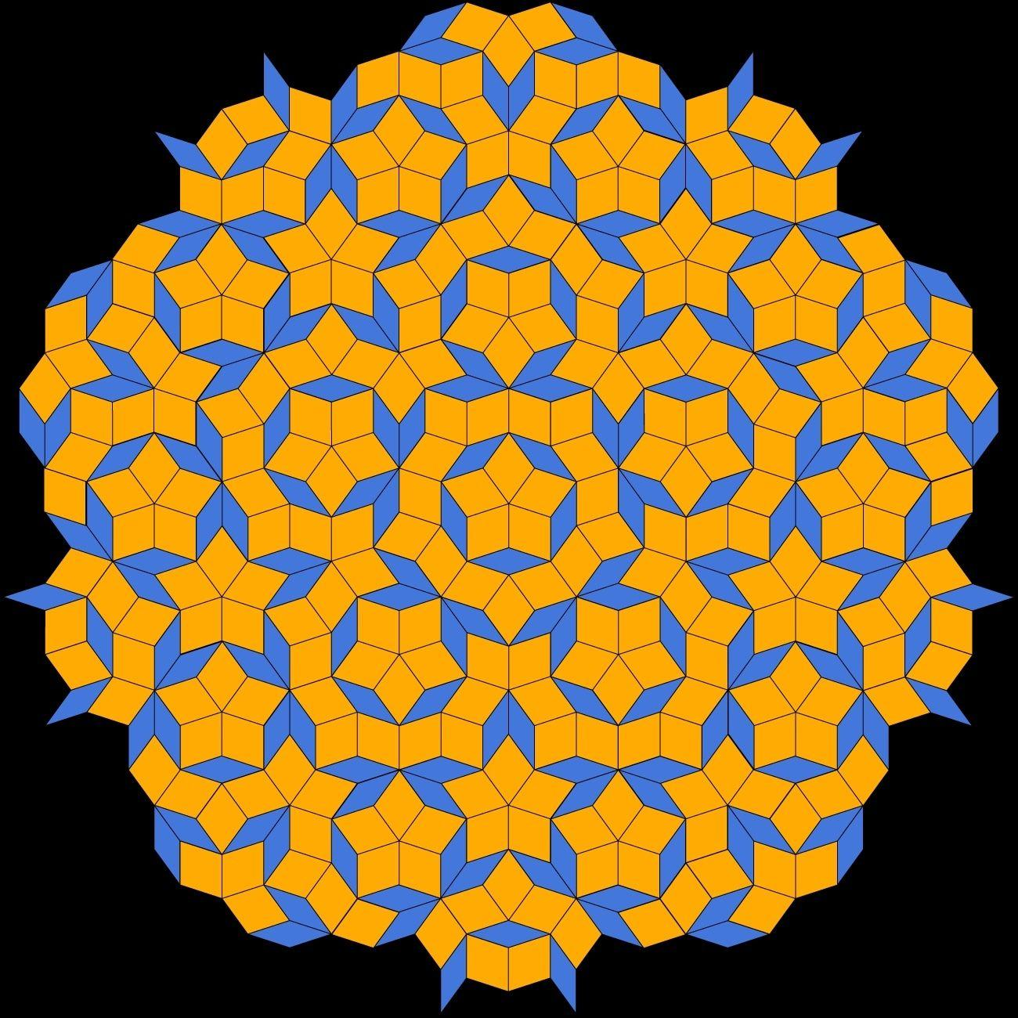
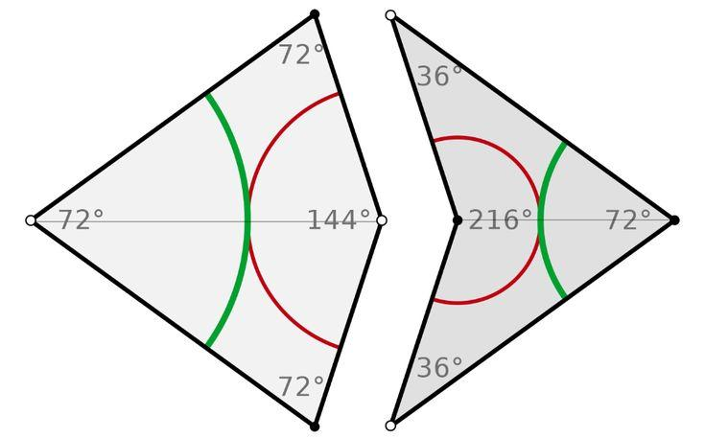
Penrose tilings can cover the plane without gaps or overlaps while having no translational period.
They exhibit remarkable mathematical order and can contain rotational symmetry.
A common Penrose tiling uses two tile shapes, such as:
- Thick rhombus
- Thin rhombus
or another equivalent pair of tile shapes.

Types of Non-Periodic Tessellations
# Source: AI Source: Provided by: [Data Path: Persons Table -> ID Column: 1, Name_En Column: Motasem Essam] -> From: [ChatGPT] on [7/25/2026]
A useful classification is:
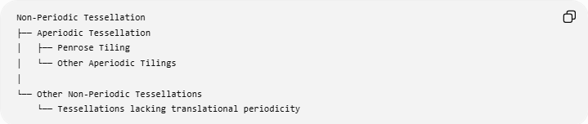
Non-Periodic Tessellation
├── Aperiodic Tessellation
│ ├── Penrose Tiling
│ └── Other Aperiodic Tilings
│
└──
└── Tessellations lacking translational periodicity
The term aperiodic should therefore not automatically be treated as exactly synonymous with non-periodic.

Symmetry
# Source: AI Source: Provided by: [Data Path: Persons Table -> ID Column: 1, Name_En Column: Motasem Essam] -> From: [ChatGPT] on [7/25/2026]
A non-periodic tessellation can still possess other forms of symmetry.
It may have:
- Rotational symmetry
- Reflection symmetry
- Glide-reflection symmetry
- Local repeating patterns
But it lacks a global translational period.
For example, Penrose tilings can exhibit fivefold rotational symmetry.
Thus:
$$\boxed{\text{No translation symmetry does not mean no symmetry}}$$

Local Repetition vs Global Periodicity
# Source: AI Source: Provided by: [Data Path: Persons Table -> ID Column: 1, Name_En Column: Motasem Essam] -> From: [ChatGPT] on [7/25/2026]
A non-periodic tessellation may contain small patterns that appear repeatedly.
For example:
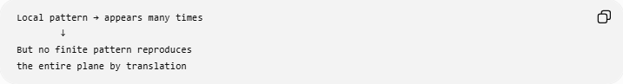
Local pattern → appears many times
↓
But no finite pattern reproduces
the entire plane by translation
Therefore, seeing repeated shapes locally does not make a tessellation periodic.
The test concerns the entire infinite pattern.

Example
# Source: AI Source: Provided by: [Data Path: Persons Table -> ID Column: 1, Name_En Column: Motasem Essam] -> From: [ChatGPT] on [7/25/2026]
Suppose a tessellation has a pattern:
A B A B A B A B ...
This has a translation period, so it is periodic.
But consider a pattern where local arrangements recur while the overall sequence never settles into a translational repeat:
A B A A B A B B A A B ...
If no non-zero translation reproduces the complete infinite pattern, it is non-periodic.

Non-Periodic Tessellation vs Irregular Tessellation
# Source: AI Source: Provided by: [Data Path: Persons Table -> ID Column: 1, Name_En Column: Motasem Essam] -> From: [ChatGPT] on [7/25/2026]
These are not the same classification.
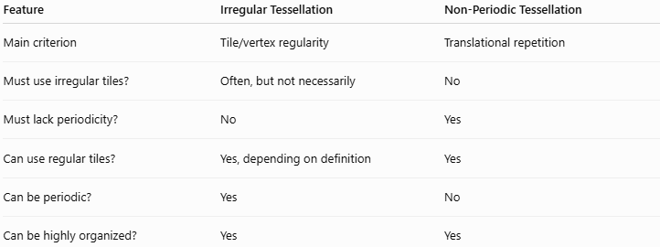
Feature | Irregular Tessellation | Non-Periodic Tessellation
Main criterion | Tile/vertex regularity | Translational repetition
Must use irregular tiles? | Often, but not necessarily | No
Must lack periodicity? | No | Yes
Can use regular tiles? | Yes, depending on definition | Yes
Can be periodic? | Yes | No
Can be highly organized? | Yes | Yes
Therefore:
$$\boxed{\text{Irregular}≠\text{Non-Periodic}}$$
An irregular tessellation can be periodic, while a non-periodic tessellation can use highly regular geometric tiles.

Relationship with Other Tessellations
# Source: AI Source: Provided by: [Data Path: Persons Table -> ID Column: 1, Name_En Column: Motasem Essam] -> From: [ChatGPT] on [7/25/2026]
For your knowledge-base structure, the classifications are best separated into two dimensions:
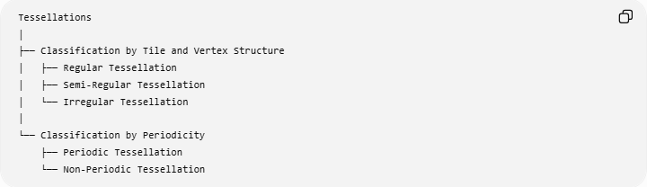
Tessellations
│
├── Classification by Tile and Vertex Structure
│ ├── Regular Tessellation
│ ├── Semi-Regular Tessellation
│ └── Irregular Tessellation
│
└── Classification by Periodicity
├── Periodic Tessellation
└── Non-Periodic Tessellation
This means a tessellation can be described using both classifications.
For example:
$$\boxed{\text{Irregular + Periodic}}$$
or:
$$\boxed{\text{Irregular + Non-Periodic}}$$
The categories are therefore not mutually exclusive.

Periodic and Non-Periodic Classification
# Source: AI Source: Provided by: [Data Path: Persons Table -> ID Column: 1, Name_En Column: Motasem Essam] -> From: [ChatGPT] on [7/25/2026]
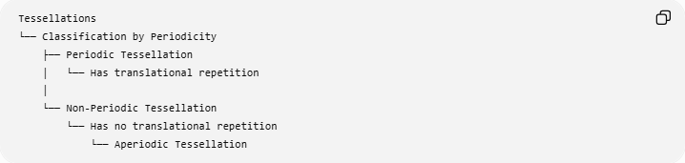
Tessellations
└── Classification by Periodicity
├── Periodic Tessellation
│ └── Has translational repetition
│
└── Non-Periodic Tessellation
└── Has no translational repetition
└── Aperiodic Tessellation

Real-World and Scientific Applications
# Source: AI Source: Provided by: [Data Path: Persons Table -> ID Column: 1, Name_En Column: Motasem Essam] -> From: [ChatGPT] on [7/25/2026]
Non-periodic structures are important in:
- Mathematical tiling theory
- Crystallography
- Quasicrystals
- Materials science
- Computer graphics
- Pattern generation
- Architectural design
- Decorative design
Quasicrystals are particularly interesting because they can exhibit long-range order without ordinary translational periodicity.

Key Points
# Source: AI Source: Provided by: [Data Path: Persons Table -> ID Column: 1, Name_En Column: Motasem Essam] -> From: [ChatGPT] on [7/25/2026]
- A Non-Periodic Tessellation has no non-zero translational period.
- It can still cover the plane completely.
- It has no gaps or overlaps.
- Non-periodic does not mean random.
- A non-periodic tessellation may still have rotational or reflection symmetry.
- Penrose tilings are important examples.
- Aperiodic is a stronger concept concerning tile sets that force non-periodicity.
- Non-periodicity is independent of whether the tiles are regular or irregular.

Conclusion
# Source: AI Source: Provided by: [Data Path: Persons Table -> ID Column: 1, Name_En Column: Motasem Essam] -> From: [ChatGPT] on [7/25/2026]
A Non-Periodic Tessellation is a plane tessellation that does not repeat through any non-zero translation. Unlike a periodic tessellation, it has no finite translational repeating unit, yet it can possess a high degree of mathematical order and symmetry. Penrose tilings provide a fundamental example of how a plane can be covered indefinitely without gaps or overlaps while remaining non-periodic.

